Butterflies in Decline

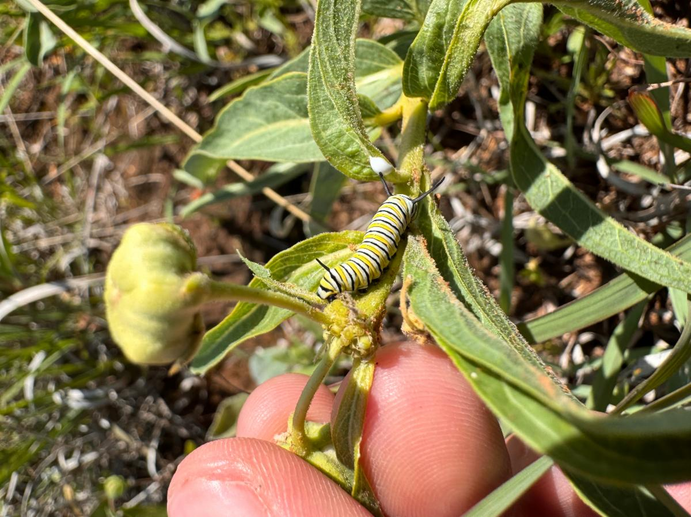

EFTA Interns Spot Monarch Caterpillar on Military Base

New Data
A new study highlights a major threat to butterfly populations in the Midwest United States. Published in PLOS ONE, the findings suggest that insecticides, especially neonicotinoids, are a key factor in the decline of butterfly numbers.

Over 17 years and across 81 counties, researchers found an alarming 8% decline in butterfly populations linked to pesticide use. The effect was even more pronounced for Monarch butterflies, with a 33% decline. This decline coincides with the widespread use of neonicotinoids, which are absorbed by plants and harm insects that feed on them.

While habitat loss and climate change are significant threats, this study suggests insecticides may be the biggest factor affecting butterfly populations in the Midwest. Neonicotinoids, already banned in Europe due to risks to bees, are extensively used in the United States. They control agricultural pests but at a significant cost to non-target species like butterflies.

Importance of Multiple Factors
The study emphasizes the need to consider multiple factors in addressing environmental issues. While habitat loss, climate change, and other threats are significant, focusing on specific causes like neonicotinoid use can offer more targeted solutions to declines.

However, the study uses data from 1998 to 2014, so recent climate impacts aren't reflected. Additionally, the major impact of glyphosate, which eliminates milkweed (the primary food for Monarch butterflies), occurred before the study period. This doesn't downplay the threat of glyphosate to Monarch butterflies but rather highlights the complexity of these issues.

World Migratory Bird Day
This news comes as World Migratory Bird Day is in full swing, with the theme "Protect Insects, Protect Birds." Our campaign shines a light on the important link between healthy insect populations and thriving bird communities. Butterflies in their caterpillar stage, and other insects, are a crucial food source for many birds, especially those that migrate. When butterfly numbers drop, it upsets this delicate balance in the ecosystem.

Environment for the Americas is not only dedicated to protecting migratory birds but also works to protect Monarch butterflies. One of our unique programs survey milkweed and butterfly populations on U.S. military installations to protect them with science-based research. These areas often offer suitable habitats, including milkweed, the sole food source for caterpillars. We work with military bases to create and maintain safe breeding grounds for Monarch butterflies.

This new study highlights why it's important to look at multiple factors when tackling environmental issues. Habitat loss and climate change are major threats, but this research shows that focusing on specific causes, like neonicotinoid use, can strengthen arguments for policy, regulation, and awareness.

This summer, as we celebrate World Migratory Bird Day and prepare for our fall peak, let us remember the interconnectedness of our shared environment. By protecting insects, we safeguard the birds that depend on them and, in turn, the health of our entire ecosystem.

