The Silent Decline of Insects

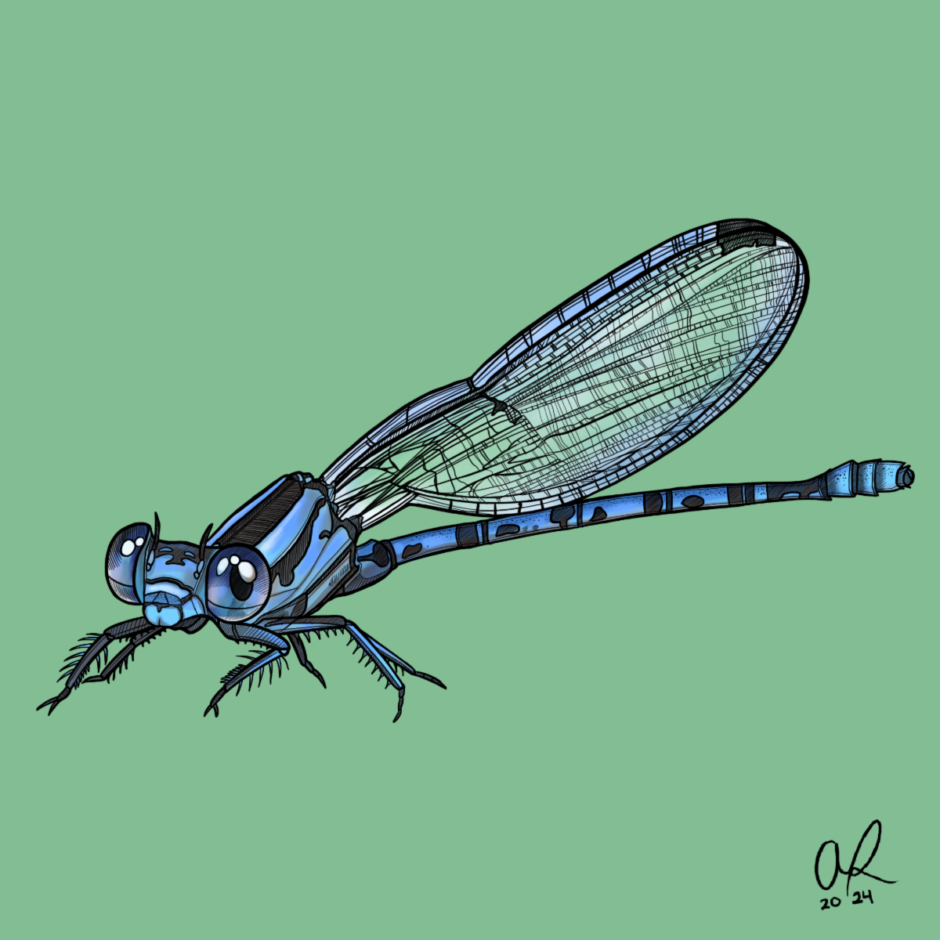

World Migratory Bird Day Illustrations by Anna Rose Paints

Our Ecosystems and Food Supply at Risk
The buzz of bees, the flutter of butterflies, and the intricate web-spinning of spiders reveals small wonders in our ecosystems. However, this small and secretive world of insects is now facing a threat. An analysis published in the journal Science in April 2020 revealed that Earth is losing roughly 9% of its land-dwelling insect population each decade. Another study from January 2021, bringing together over 80 insect research findings, pointed out a yearly decrease in insect abundance of around 1% to 2%, which differs from the human population's growth of just under 1% each year.

In terms of biodiversity, insects rule supreme, making up over two-thirds of the world's 1.5 million documented animal species. Scientists suggest that there are probably many more insect species out there waiting to be found. The Animal Kingdom includes around 73,000 vertebrates like apes, birds, and fish, which is just a tiny fraction (less than 5%) of all the different species we know about.

Representing a vast majority of Earth's animal species, insects are crucial not only for themselves but also for the birds and all other life that depends on them for sustenance. The value of insects can't be overstated; Pollinators alone bring life to more than 75% of our crops.

Yet, a 5-10% decline in insect numbers has been observed over the past century and a half. Deforestation, industrial agriculture, light pollution, and climate change are major factors driving this trend. Our use of pesticides not only affect pests but also harm beneficial insects and the animal that eat them.

Echoes Through the Food Chain
The iconic barn swallow, known for signaling spring's arrival, faces a concerning population decline, similar to house martins and swifts. This decline is linked to reduced insect numbers in their habitat, highlighting the connection between bird species and insects.

The United States and Canada have observed a concerning decline, with a significant 29% drop in bird populations since 1970, equating to around 2.9 billion fewer birds.

What We Know, and What We Don't
Recent 2021 data from the International Union for Conservation of Nature (IUCN) shows that only 1% of the around 1 million identified insect species have been assessed for conservation. This rate matches bird species and exceeds that of mammals. Despite these stats, prioritizing insects remains a challenge.

Protect Insects, Protect Birds
Conservation initiatives often focus on charismatic vertebrates, but it is important come together to support less popular but equally significant species. Insects, though small, impact ecological and food systems greatly. Protecting insects protects beloved songbirds too.

We must forge a new path — one where we reduce pesticide use, reigning in habitat destruction, and responding to climate change with urgency. Educating communities, supporting sustainable farming methods, and funding research can also turn the tide. Small gestures in gardens and urban areas, such as planting native plants and reducing light pollution, can protect our local environments.

And so, we move forward with the knowledge that our actions, though seemingly small as the insects we champion, have the power to reverberate through the food web and across the globe. With informed strategies and a collective commitment to nature, we can create a chorus of life vibrant enough to sustain our environments, our migratory birds, and ultimately, ourselves.

Advocate, educate, and participate in conservation efforts to protect our insects. For when we protect insects, we protect birds.

