Fireflies: Can We Save Them? Rachel Carson Council
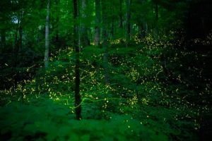
Credit: Saul Young/News Sentinel
Growing up, whenever we visited family on the East Coast, it was a guarantee that we would be greeted by fireflies (lightning bugs) at dusk. As the bright afternoon transitioned to a moodier and sometimes rainy evening with the constant din of cicadas and crickets, fields and parks would become a twinkling patchwork. the fireflies, blinking in their own Morse code, were trying to find a mate. As a kid, they were truly a magical sight, a marvel of nature. What better reason to go for night hikes and explore the beauty of nearby parks in the evening than an insect whose glowing mating ritual attracts the awe-filled attention of the human species as well as potential mates.
I now work for the Rachel Carson Council in Washington, D.C., but it’s been a while since I’ve seen a firefly. Boston is a bit too cold, and I haven’t been in Durham during the warmer months long enough to see the fireflies come out. Upon arriving in D.C., they were an afterthought, long since forgotten and left behind in a more leisurely time. It was not until the end of my first week, when I was out on the Mall with some friends and ice cream (a scoop each of turmeric mango and dark chocolate), that I kept catching flashes in my peripheral vision. Perhaps? Could it be? It had been a while since I saw one; close to 4 or 5 years. The other evening, however, after a particularly good couple of games of beach volleyball at the Lincoln Memorial Courts, I finally witnessed a flotilla of fireflies flickering between the trees.
In the District, one of the most commonly seen fireflies, the Dot-Dash, is currently declining in population and is listed as vulnerable by the International Union for Conservation of Nature (IUCN). The IUCN is considered the global standard for the estimation of species extinction and lists each species individually, with all known facts about the species such as range, vulnerability and habitat.
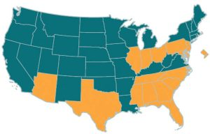The Lampyridae family — the charismatic beetle known for its bioluminescent signals and referred to as the firefly or lightning bug — seems to be declining. Numerous anecdotal reports indicate a decline, and a recent study has found that at least 18 firefly species are at risk. Overall, the extent to which fireflies are endangered is unknown, as this family of insects is in need of more studies, considering that more than half of the species were not evaluated or had insufficient data. The study, however, did find that 14% of all Lampyridae species are threatened with extinction, either categorized as Critically Endangered, Endangered or Vulnerable.
The main suspected drivers of decline are habitat degradation and loss, light pollution, pesticide use, climate change, and invasive species. Surprisingly, during its lifecycle, the firefly spends the majority of its time underground, feeding on slugs and snails as larvae, waiting for the right moment to become an adult, where it will only live for a few weeks. In general, moisture is critically important during all firefly life stages to prevent desiccation (removal of moisture), to which eggs, larvae and flightless females are particularly susceptible. Therefore, drought is one of the biggest threats to the species, with habitat loss being a close second. Wetland habitats overall are in decline throughout the US, especially in the Southeast and Northeast, where firefly species richness is highest. Loss of wetlands due to sea level rise will further speed up this decline.
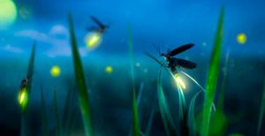Suffice to say, fireflies are one insect in a collection of many others who face the effects of pesticide use and the impacts of climate change, threatening their populations. Experts say that over 40% of insect species, including fireflies, are threatened with extinction. The Dot-Dash firefly in particular faces extensive decreases in its range as wetlands and other habitats are developed or face the impacts of sea level rise. Use of pesticides on pests like mosquitos simultaneously threatens firefly larvae as well as the critters they feed on. Manicured lawns are not good for fireflies, who are searching for snails and slugs. Improving both biodiversity and decreasing or ending pesticide use will help immensely, as well as using porch lights as little as possible to reduce light pollution. And messy is good for fireflies. Leaving woody debris and leaf litter around the edges lawns and gardens will also help. So, too, will planting native shrubs and trees and turning off all lights when not using them.
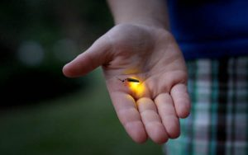Mesmerizing moments out in a field watching fireflies dance is reason enough to preserve them for future generations. You can keep their magic alive with even a few simple actions. Let your lawn grow longer or slowly replace it with native plants since typical showpiece lawns require tending, mowing, and the use of herbicides and pesticides. Go organic. Or if you must, use only small amounts of pesticides on specific, targeted areas, as opposed to spreading them across your entire property. And, finally, join with friends and neighbors in creating and weaving patches of habitat for fireflies, pollinators, and birds throughout your larger neighborhood. Such interconnected areas are where populations of fireflies are most likely to succeed. Then, as you walk and meander, you will be greeted by the scents and beauty of colorful flowers, native plants and shrubs by day. At night, you will be transported into a twinkling, starry world of wonder and awe as gentle fireflies surround you and, upon occasion, softly land and light up your hand.

