What to keep in mind for the safety of your pets as cicadas emerge
Two broods of cicadas are emerging at around the same time this spring.
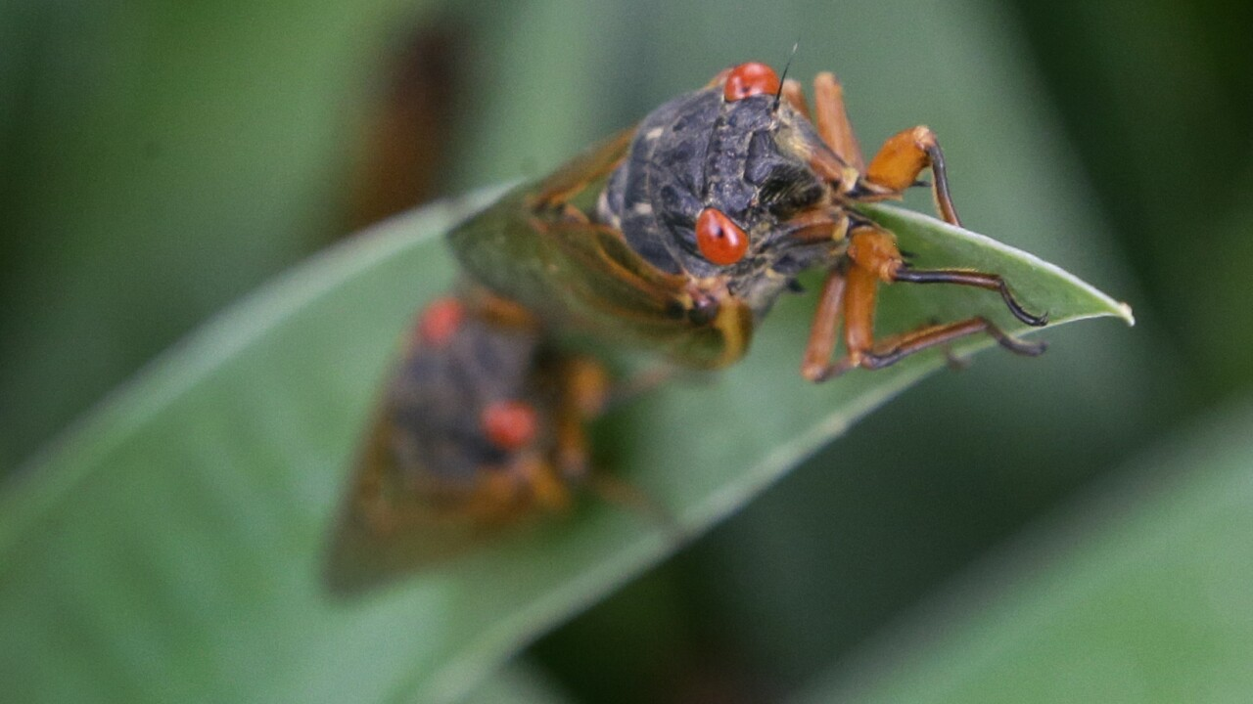
Photo by: Orlin Wagner/AP
A periodical cicada.

By: Chloe Nordquist
Posted at 4:51 PM, Apr 24, 2024
The cicadas are coming! Should you be concerned about your pets?
“Just don't let them eat too many. Great time to work on some training, great time to work on ‘drop it’ or ‘leave it’,” said Sandra Faeh, president-elect of the American Veterinary Medical Association.
“They are excited about these things that are moving around and flying a little bit and want to chase and catch them, so don't stick your hand in their mouth, don't get bit. It's OK if they eat one or two,” she explained.
Luckily, cicadas are not toxic to cats and dogs. They also don’t sting or bite. But if your pet eats too many, it could cause an upset stomach.
“The discarded shells are a little sharp and even a little brittle so there is a small chance that they may irritate when they swallow them, or they may kind of gag or act like they're choking, so if anything like that happens, please call your veterinarian right away,” Faeh said.
Billions of cicadas will emerge in the coming weeks.
Two separate broods, or groups, will surface at the same time.
Brood XIII has a 17-year life cycle and consists of three species, while Brood XIX has a 13-year life cycle with four species. These two broods reaching adulthood at the same time is rare. It won’t happen again until 2245, according to experts.
The two groups will emerge from Iowa, to Mississippi, to Tennessee.
Scripps News has a map available here to show you what broods will surface where.
So what about the noise?
Experts say cicadas can be as loud as a motorcycle or a leaf blower.
“[Pets] tolerate that constant steady [noise] much better than they'd tolerate something like a firework or a siren, or thunder, something just all of a sudden,” Faeh said.
“Your pets are going to react in different ways but the bottom line is they are pretty safe, very little risk,” she said.

